|  |
| --- |
| NewLogo.png |
| HR-CMS |
|  |
| FOR |
| **OFFER LETTER MODULE** |
|  |

|  |
| --- |
|  |

TABLE OF CONTENTS

INTRODUCTION 3

HR - CMS MODULE INTRODUCTION 4

OFFER LETTER MODULE 4

OFFER LETTER 5

1.1 HOW TO GENERATE NEW OFFER LETTER 5

# INTRODUCTION

**System Introduction**

Human Resource Management System (HR-CMS) is a web base application that uses to help Human Resources Department to record and manage all data about staff in City University.

**HR - CMS User Manual**

This user manual was design to assist user a step by step instruction on how to use the system. This manual is meant for the Human Resources Department.

**The Objective**

The objective of this manual is to provide a step by step instruction for user to use the system. This manual will provide user an instruction with a system screen shot and also the sequence on how to use each function in certain module. In this manual, user will be given a simple tips or reminder about the system.

# HR - CMS MODULE INTRODUCTION

## OFFER LETTER MODULE

**Introduction**

Offer Letter module is use to generate an appointment letter for any new staff in City University.

**Module Ownership:** This module is owned and use by the Human Resources Department.

**Maintained By:** CMS Team..

***Remarks***

*Any suggestion for system upgrade is highly welcomed. Please send your feedback to us at* [sysadmin@city.edu.my](mailto:sysadmin@city.edu.my).

# OFFER LETTER

## 1.1 HOW TO GENERATE NEW OFFER LETTER

# 

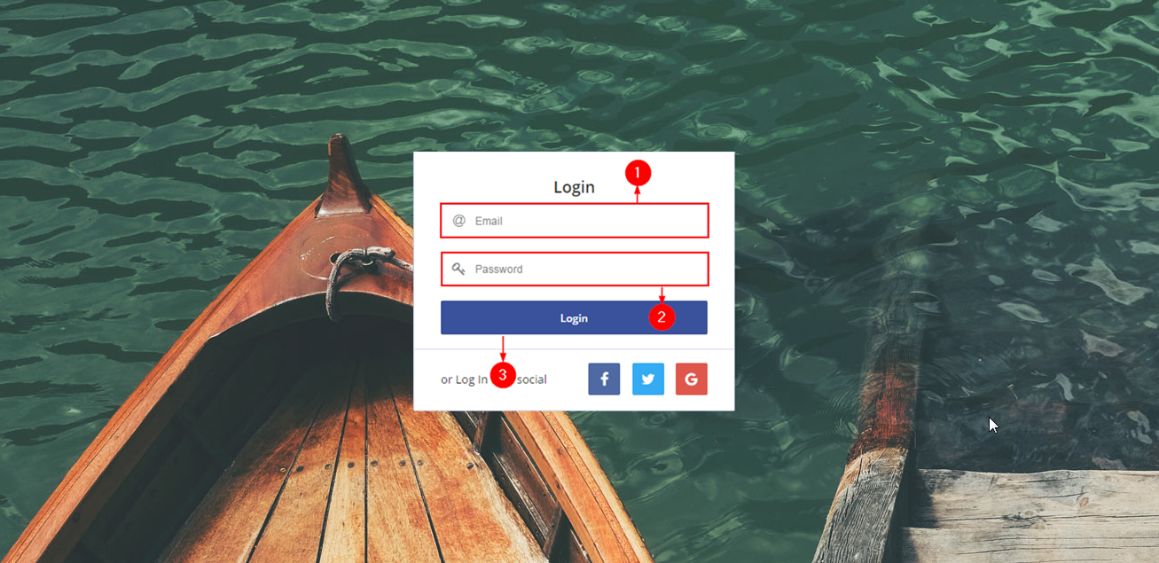

**Steps:**

1. Keyin your city u email. *(Without @city.edu.my)*
2. Keyin your password
3. Click the "**Login**" button.

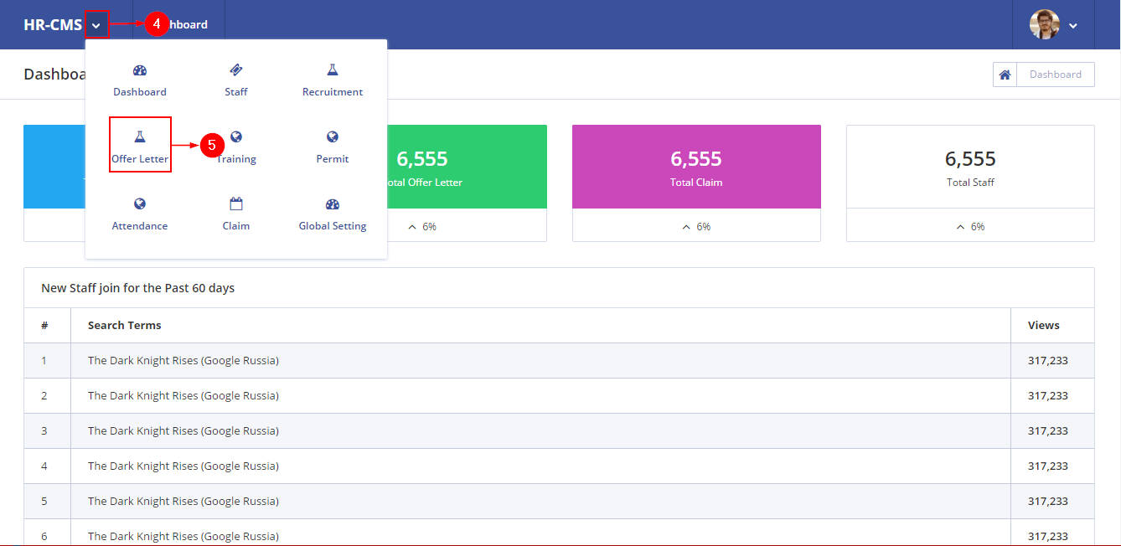

**Steps :**

1. Click the down arrow to view the menu.
2. A dropdown menu appear. Click "**Offer Letter**" icon.

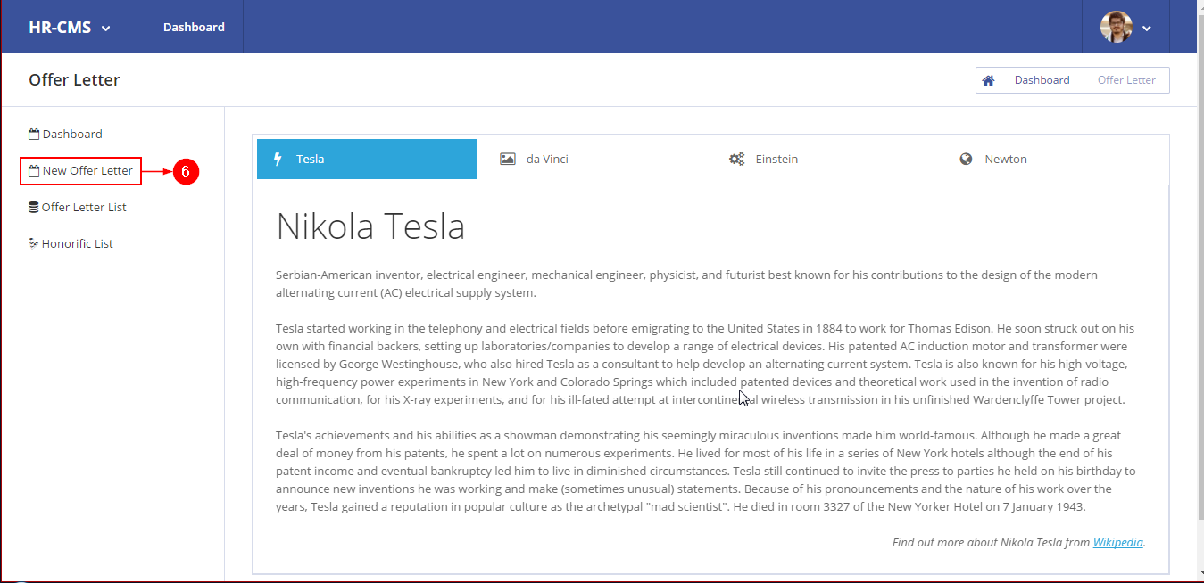

**Steps:**

1. On the side menu, you will see a list of menu. Click the "**New Offer Letter**" button.

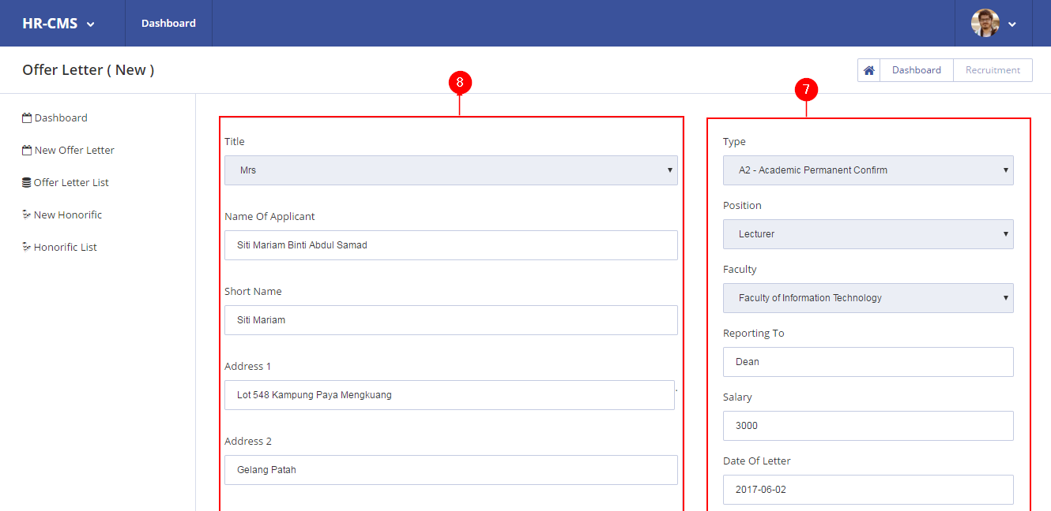

**Steps :**

1. To create new letter, you need choose the offer letter type and fill in the new staff appointment details.
2. Keyin the details of the new staff.

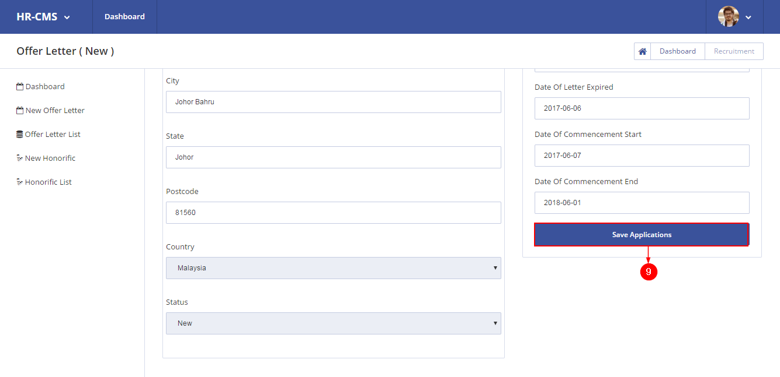

**Steps :**

1. Once finish, click the "**Save Application**" button.

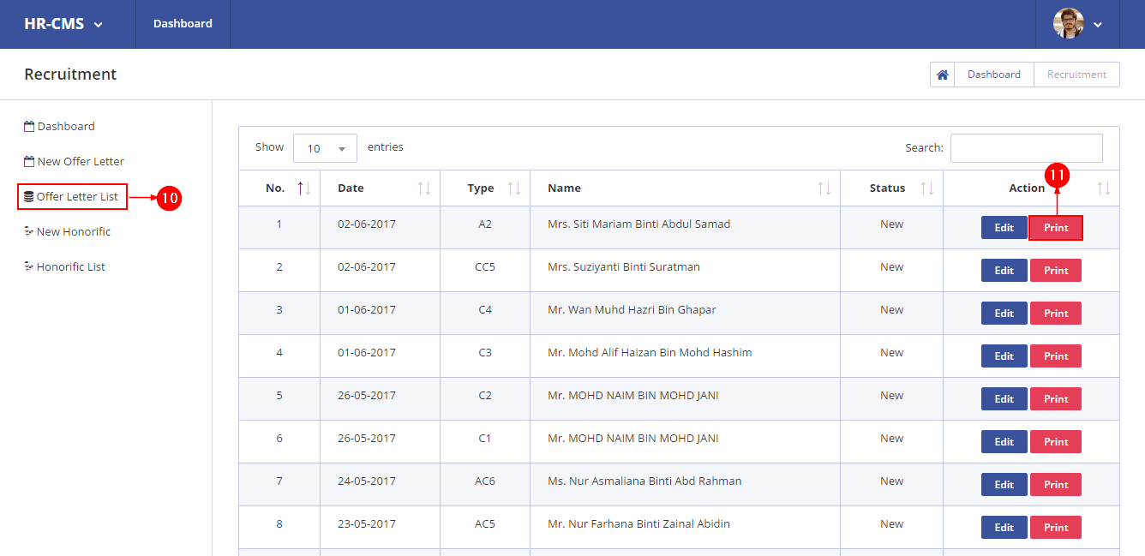

**Steps :**

1. To view the new letter, click the "**Offer Letter List**" on the left menu.
2. You will see the list of offer letters that have been created. To print this letter, click the "**Print**" button.
3. The letter will be view in pdf format. Sample of letter is shown below :

